ATTENDANCE TRACKER

A Project Report submitted
In partial fulfillment of the requirements for the award of the degree
of

BACHELOR OF TECHNOLOGY
IN
COMPUTER SCIENCE & ENGINEERING (DATA SCIENCE)

Submitted by
BAIPOTHU KAVYA
Registration No-2025040821

Under the esteemed guidance of

Dr Devarapalli Ravi Kishore, CSE



DEPARTMENT OF COMPUTER SCIENCE AND ENGINEERING (DATA SCIENCE)
GITAM SCHOOL OF TECHNOLOGY
GITAM (Deemed to be University)
VISAKHAPATNAM
2026

DEPARTMENT OF COMPUTER SCIENCE AND ENGINEERING
(DATA SCIENCE)
GITAM SCHOOL OF TECHNOLOGY
GITAM (Deemed to be University)



DECLARATION

I hereby declare that the project report entitled “ATTENDANCE TRACKER” is an original work done in the Department of Computer Science and Engineering (Data Science), GITAM School of Technology, GITAM (Deemed to be University) submitted in partial fulfillment of the requirements for the award of the degree of B.Tech. in Computer Science and Engineering. The work has not been submitted to any other college or University for the award of any degree or diploma.

Date:

Registration No Name Student Signature
2025040821 Baipothu Kavya

DEPARTMENT OF COMPUTER SCIENCE AND ENGINEERING
(DATA SCIENCE)
GITAM SCHOOL OF TECHNOLOGY
GITAM (Deemed to be University)



CERTIFICATE

This is to certify that the project report entitled “ATTENDANCE TRACKER”
is a Bonafide record of work carried out by Baipothu Kavya, Registration No - 2025040821, submitted in partial fulfillment of requirement for the award of degree of Bachelors of Technology in Computer Science and Engineering (Data Science).

Date:

Project Guide
Dr. Devarapalli Ravi Kishore
Assistant Professor
ACKNOWLEDGEMENT
I would like to express my sincere gratitude to all those who have supported and guided me throughout the course of this project.
First and foremost, I extend my heartfelt thanks to Ashrita and Sailusha for their invaluable assistance and unwavering support, which were instrumental in the successful completion of this project. Their extensive knowledge and profound insights greatly influenced the direction and outcome of my work.

I am deeply indebted to Dr. Devarapalli Ravi Kishore for his significant contributions and continuous support. His expertise and guidance were pivotal in overcoming the challenges encountered during various stages of this project.
Lastly, I would like to express my appreciation to my team members for their constant support and motivation. Their belief in my abilities gave me the strength to persevere and strive for excellence.

TABLE OF CONTENTS

S.No. | Description | Page No.
1. | Abstract | 6
2. | Introduction | 7
3. | Aim of the Project | 8
4. | Problem Definition & Objectives | 9
5. | Coding | 10 - 13
6. | Test Cases | 14
7. | Output Screens | 16
8. | Future Work | 16
9. | Conclusion | 17

1.ABSTRACT
The Attendance Tracker is a Python-based application designed to maintain and manage student attendance digitally. The system allows the user to add student names, mark attendance, view attendance records, and calculate attendance percentage. The project reduces manual work and helps in maintaining accurate attendance records. The system uses Python programming concepts such as lists, functions, loops, conditional statements, and file handling to store and retrieve attendance data. This project is useful for schools and colleges to manage attendance efficiently.

2.INTRODUCTION

Attendance management is an important task in schools and colleges. Traditionally, attendance is recorded manually on paper, which is time-consuming and may lead to errors. Maintaining and calculating attendance manually becomes difficult when the number of students increases.
The Attendance Tracker project is developed to automate the attendance system using Python. This system helps in adding student details, marking attendance, storing attendance records, and calculating attendance percentage automatically. The project demonstrates how Python programming can be used to solve real-world problems and develop useful applications.

3.AIM OF THE PROJECT

The main aim of this project is to design and develop an Attendance Tracker system using Python programming that helps in maintaining and managing student attendance records in a digital and efficient manner. The system is developed to replace the traditional manual attendance system, which is time-consuming, difficult to maintain, and prone to human errors.
This project aims to create a simple and user-friendly software application that allows the user to add student details, mark attendance, store attendance records, and calculate attendance percentage automatically. The system uses file handling in Python to store and retrieve attendance data, ensuring that the data is stored safely and can be accessed anytime.
Another aim of this project is to apply the basic concepts of Python programming such as functions, loops, conditional statements, lists, and file handling in a real-world application. This project helps in understanding how Python can be used to develop useful software applications for educational institutions.
The project also aims to reduce paperwork, save time, and improve accuracy in attendance management. It provides an organized way of storing attendance records and helps teachers to easily track student attendance and performance.
Furthermore, the project is designed in such a way that it can be enhanced in the future by adding advanced features such as a graphical user interface, database connectivity, login system, report generation, and face recognition-based attendance system.
In summary, the aim of this project is to develop an efficient, reliable, and user-friendly Attendance Tracker system using Python that simplifies attendance management and demonstrates the practical implementation of programming concepts.

4.PROBLEM DEFINITION & OBJECTIVES

Problem Definition
Manual attendance tracking is time-consuming and difficult to maintain for a large number of students. There is a possibility of calculation errors and data loss. Therefore, a computerized system is required to store attendance data safely and calculate attendance automatically.
Objectives
- To create a system to add student names.
- To mark attendance of students.
- To store attendance data using file handling.
- To calculate attendance percentage.
- To display attendance records.
- To reduce manual errors and save time.

5.CODING
import os

students_file = "students.txt"
attendance_file = "attendance.txt"

# Add student
def add_student():
name = input("Enter student name: ")
with open(students_file, "a") as f:
f.write(name + "\n")
print("Student added successfully.")

# Mark attendance
def mark_attendance():
if not os.path.exists(students_file):
print("No students found.")
return

with open(students_file, "r") as f:
students = f.readlines()

with open(attendance_file, "a") as f:
for student in students:
student = student.strip()
status = input(f"Is {student} present? (P/A): ")
f.write(student + " - " + status + "\n")

print("Attendance marked successfully.")

# View attendance
def view_attendance():
if not os.path.exists(attendance_file):
print("No attendance records found.")
return

with open(attendance_file, "r") as f:
print("\nAttendance Records:")
print(f.read())

# Calculate attendance percentage
def calculate_percentage():
if not os.path.exists(attendance_file):
print("No attendance records found.")
return

total = 0
present = 0

with open(attendance_file, "r") as f:
for line in f:
total += 1
if "P" in line:
present += 1

if total == 0:
print("No attendance data.")
else:
percentage = (present / total) * 100
print("Attendance Percentage:", percentage, "%")

# Main menu
while True:
print("\n--- Attendance Tracker ---")
print("1. Add Student")
print("2. Mark Attendance")
print("3. View Attendance")
print("4. Calculate Attendance Percentage")
print("5. Exit")

choice = input("Enter your choice: ")

if choice == "1":
add_student()
elif choice == "2":
mark_attendance()
elif choice == "3":
view_attendance()
elif choice == "4":
calculate_percentage()
elif choice == "5":
print("Exiting program.")
break
else:
print("Invalid choice. Try again.")

5.TEST CASES

Test Case | Input | Expected Output | Result
Add Student | Enter name | Student added | Pass
Mark Attendance | P/A input | Attendance stored | Pass
View Attendance | Option 3 | Records displayed | Pass
Calculate % | Option 4 | Percentage shown | Pass
Invalid Choice | Wrong input | Error message | Pass

7.OUTPUT SCREEN

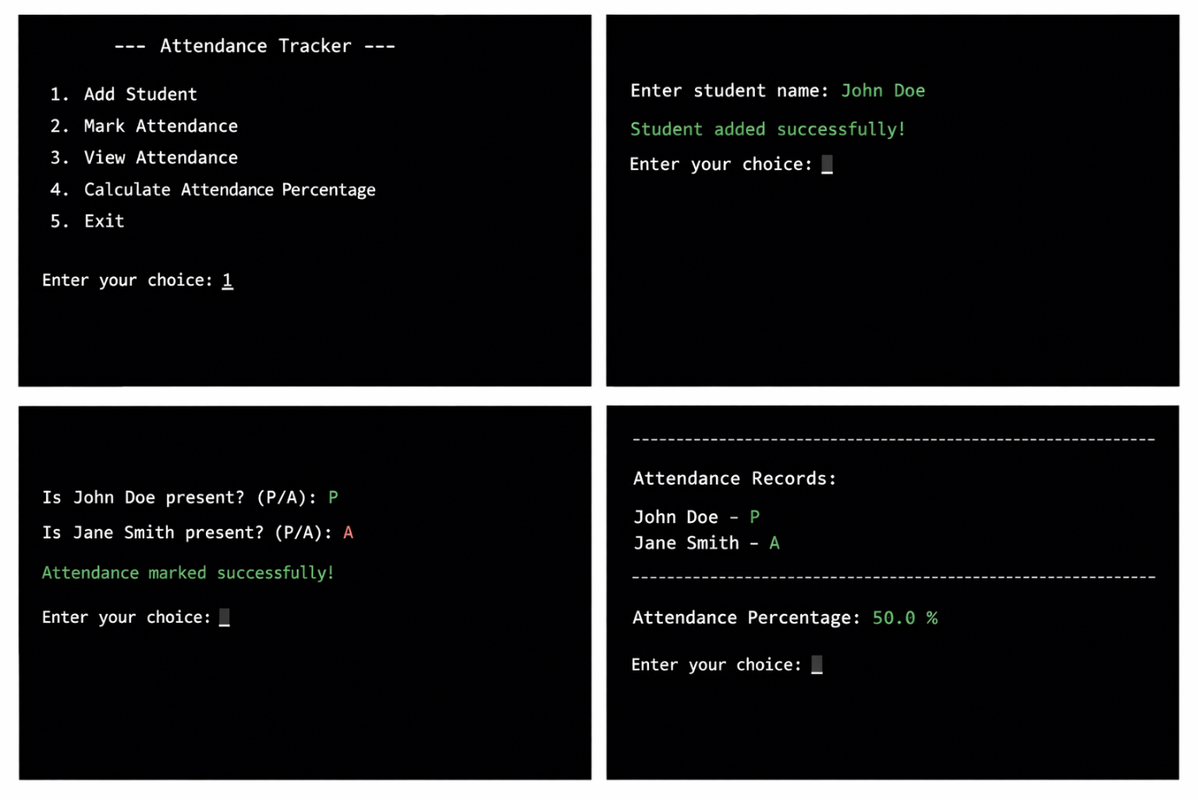

8.FUTURE WORK
The Attendance Tracker developed in this project is a basic system created using Python and file handling. However, the system can be further improved by adding more advanced features to make it more efficient and user-friendly.
In the future, a Graphical User Interface (GUI) can be developed using Python libraries such as Tkinter so that users can interact with the system easily without using the command prompt. A login system can also be added so that only authorized users such as teachers or administrators can access and modify the attendance records.
The project can also be improved by using a database such as MySQL or SQLite instead of text files for storing attendance data. This will make the system faster, more secure, and capable of handling large amounts of data.
Additional features such as automatic report generation, monthly attendance reports, and sending attendance notifications to students can also be added. Face recognition-based attendance systems and web-based attendance systems can also be developed in the future to make the system more advanced and automated.
Thus, the project has many future enhancements and can be developed into a complete attendance management system.

9.CONCLUSION

The Attendance Tracker project was successfully designed and implemented using Python programming. The system helps in maintaining student attendance records in a simple and efficient way. It allows the user to add student names, mark attendance, view attendance records, and calculate attendance percentage automatically.
This project helped in understanding the practical implementation of Python concepts such as functions, loops, conditional statements, and file handling. The system reduces manual work, saves time, and minimizes errors in attendance calculation.
The project demonstrates how programming can be used to solve real-world problems and develop useful applications. The Attendance Tracker is a simple, user-friendly, and efficient system that can be used in schools and colleges for managing attendance digitally. The system can be further improved by adding advanced features in the future.

